The Learning Technology Guide
USER INSTRUCTIONS
LEARNING TECHNOLOGY GUIDE TOUR

USER INSTRUCTIONS
- What is the Learning Technology Guide?

How to use the Learning Technology Guide?
  - Get Started
  - Keyword Search
  - Category or Tag Search
  - Ratings Information
- Request a technology review
- Rate a technology

Image source:
https://securityonline.info/top-benefits-of-using-technology-in-education/

What is the Learning Technology Guide?
The Centre for Innovation in Teaching and Learning has created the Learning Technology Guide as a fast and easy way for instructors to find new or alternative tools that help address specific instructional issues. The Learning Technology Guide provides an overview of a variety online platforms and tools to help make teaching and learning easier for all. Each tool listed in the Learning Technology Guide has been investigated and assessed using the Rubric for Learning Technology Evaluation.

How to use the Learning Technology Guide?
Get Started
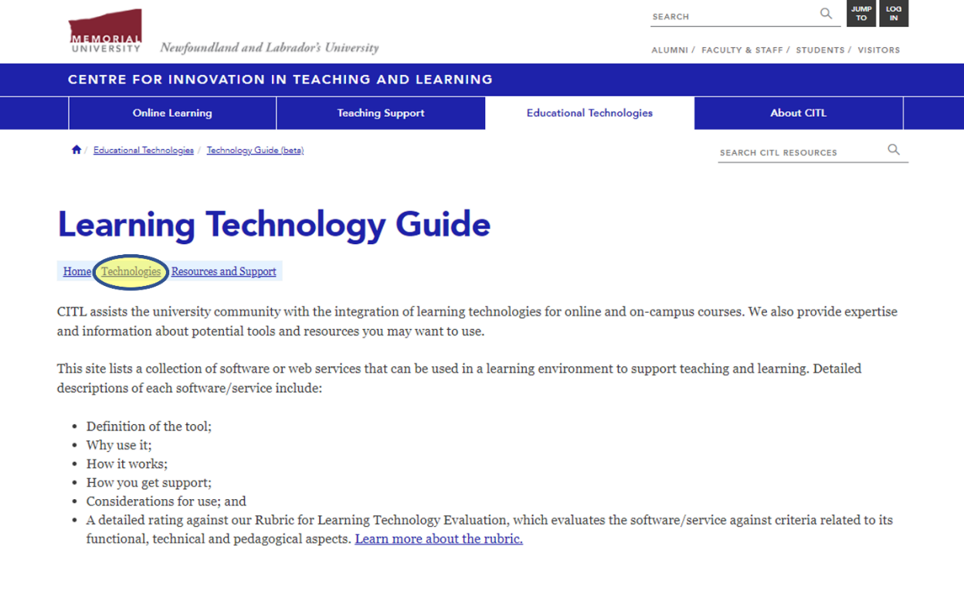
Once you are on the Learning Technology Guide Home page, click on Technologies:

The technologies are presented in a table in alphabetical order. Users can also choose to look for technologies based on their category, which corresponds with their most common use. Each technology entry also shows a brief description of the tool that can aid in choosing the correct tool for the instructors’ need.
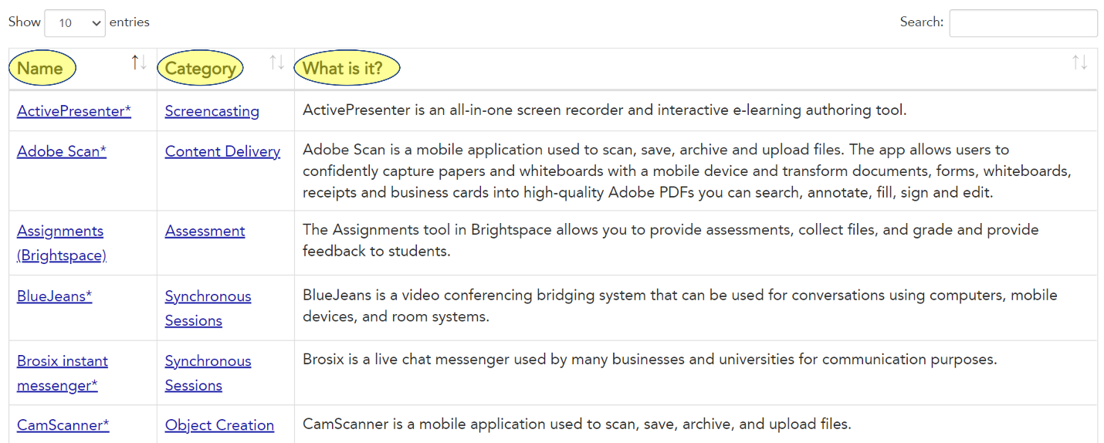

Keyword search
If you know the name, the category, or the tag of the tool that you wish to use, please use the search function to see if it has been investigated and evaluated by CITL.
All third-party tools which are not supported by the university are indicated by an asterisk (*) following the name of the tool.
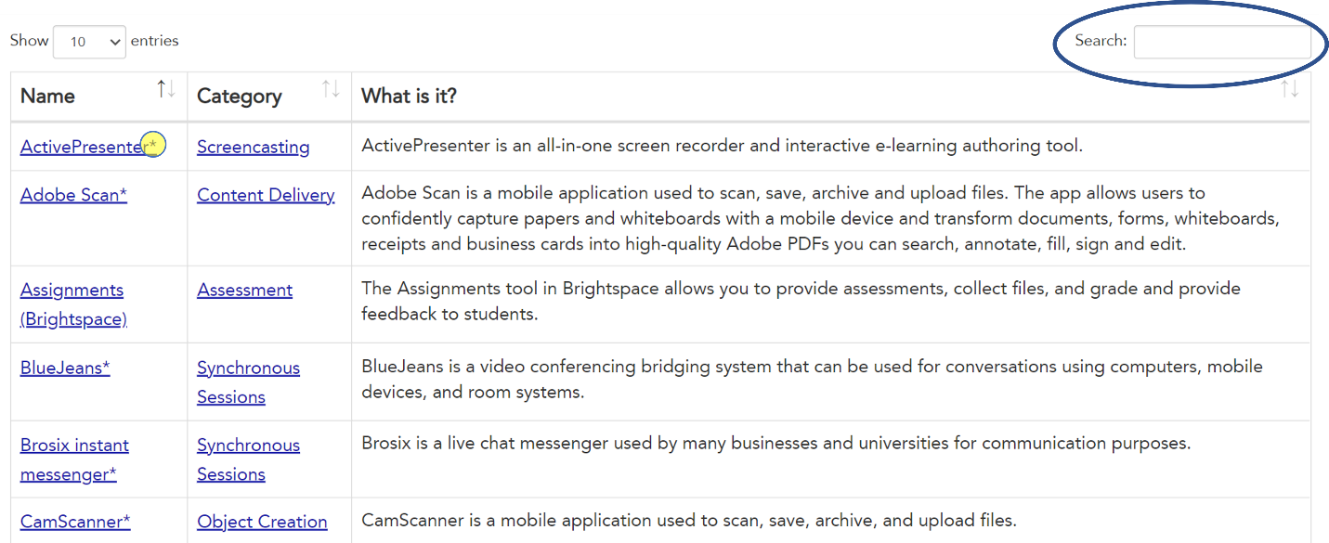

Category or Tag Search
If you would like to see different categories and tags available for the investigated and reviewed learning technologies, you can select Tag or Category on the main page of the Learning Technology Guide
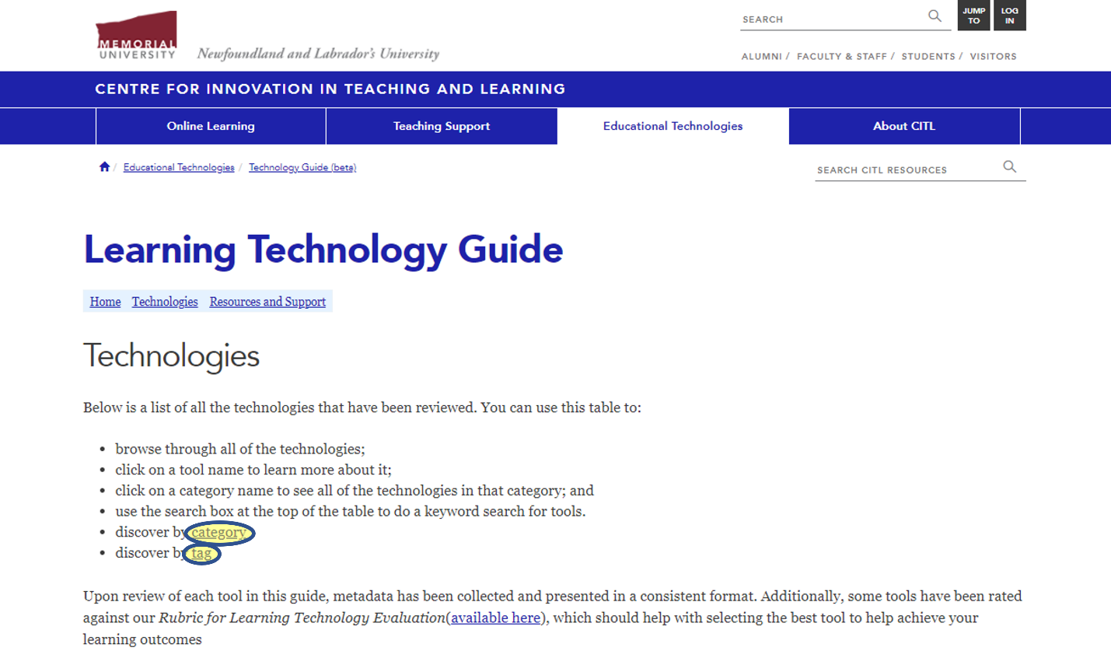

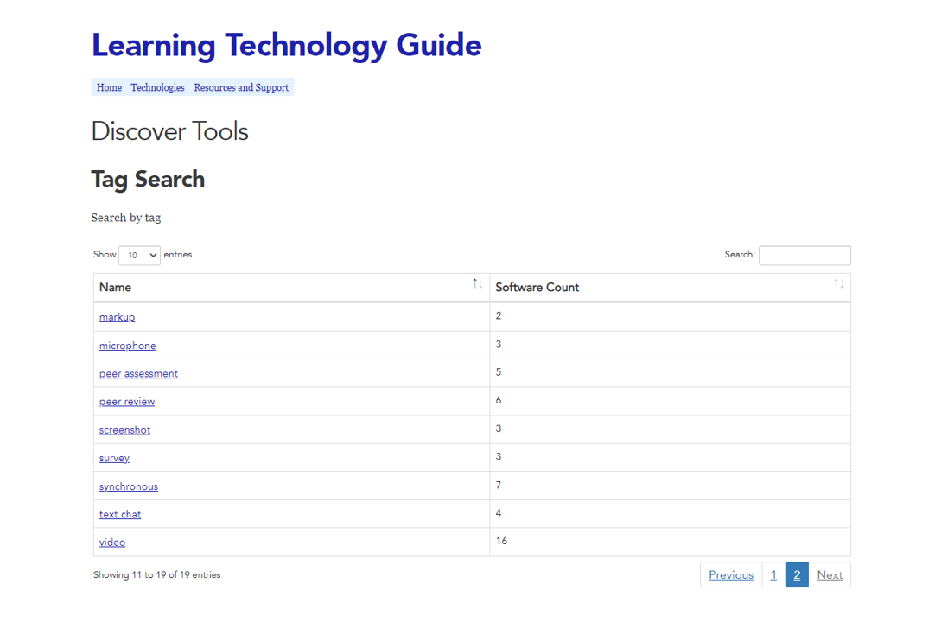
The Tag Search webpage will show a list of the tags available for the reviewed and investigated learning technologies. Each tag entry also displays the number of platforms and tools available within that group. To see what learning technologies are associated with a tag, you can click on the tag name.

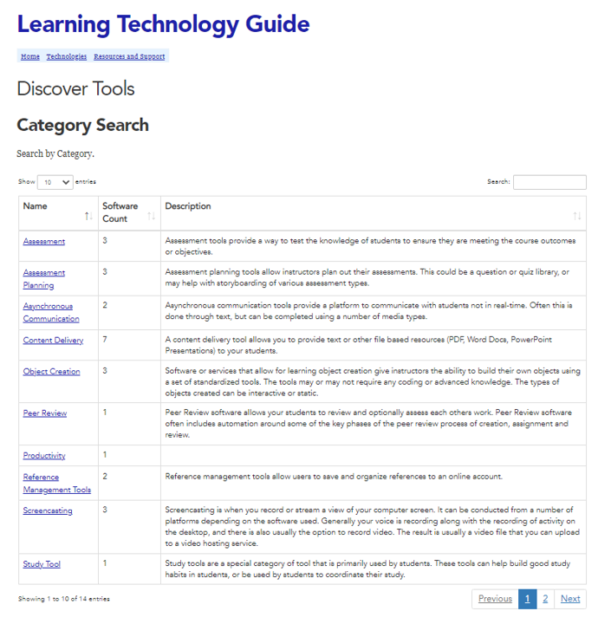
The Category Search webpage provides a list of the categories for the investigated and reviewed learning technologies. The list provides the name of the category, the number of learning technologies within that category as well as a description of the types of learning technologies that fall within a specific category. To see the platforms and tools within a category, you can select the name of the category.

Ratings Information
The detailed Ratings Information allows users to see the criteria used to evaluate technologies.
Once you are on a particular technology’s page, you can see the detailed ratings of this tool, by selecting the desired criterion in the chart. Three stars (★★★) is the highest rating, and one star (★☆☆) is the lowest. The “prohibited” sign (🛇) shows that the tool is not intended to accomplish the goals of a category.
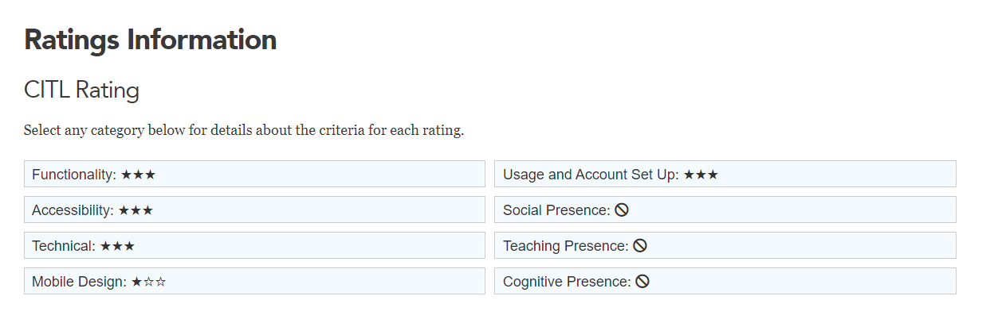

Did not find what you were looking for?
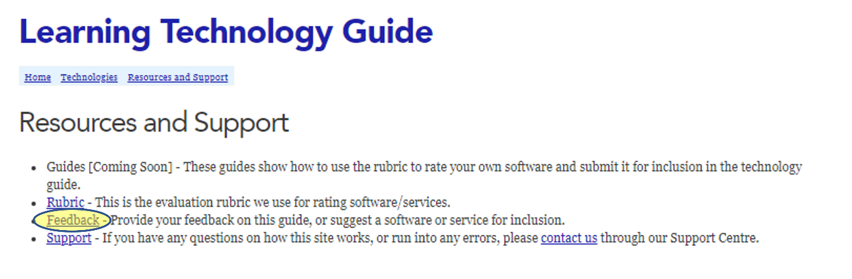
If you were not able to find a learning technology that could be used in your instructional situation, you can submit a request to have a specific tool investigated and reviewed for you.
To submit a request, please email ltc_citl@mun.ca

Would like to share your experience with educational technologies with us?
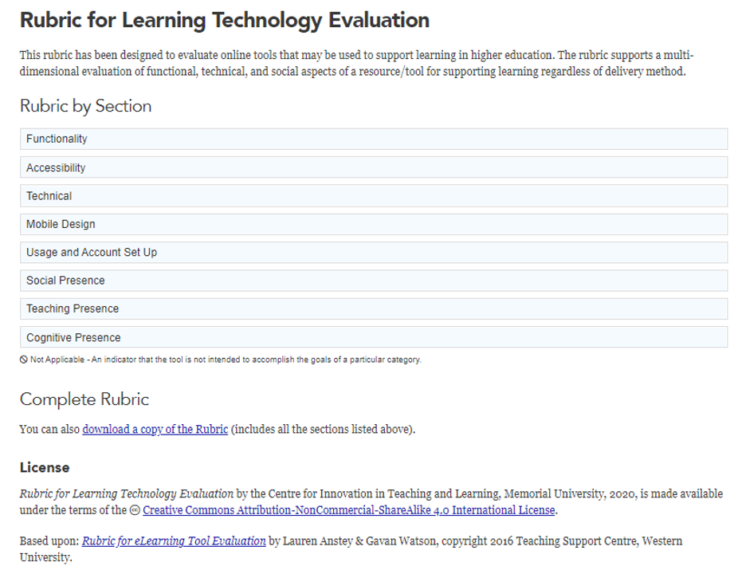
You can submit a review or a completed rubric: link ?
Please send your review of a technology to ltc_citl@mun.ca

LEARNING TECHCOLOGY GUIDE TOUR

Image source: https://www.hrtechnologist.com/articles/learning-development/how-technology-enables-personalized-learning/#lg=1&slide=0

Instructional Situation
I am looking for tools that will allow me to easily annotate while presenting a PowerPoint slide when recording a lecture.

Using the Guide
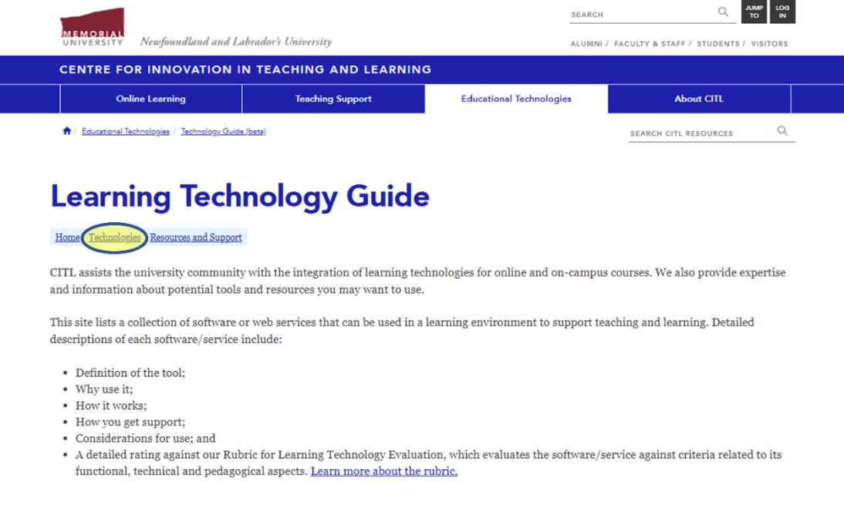
Once you are on the Learning Technology Guide Home page, click on Technologies:
Once you are on the Technologies page, select the option to discover by category:
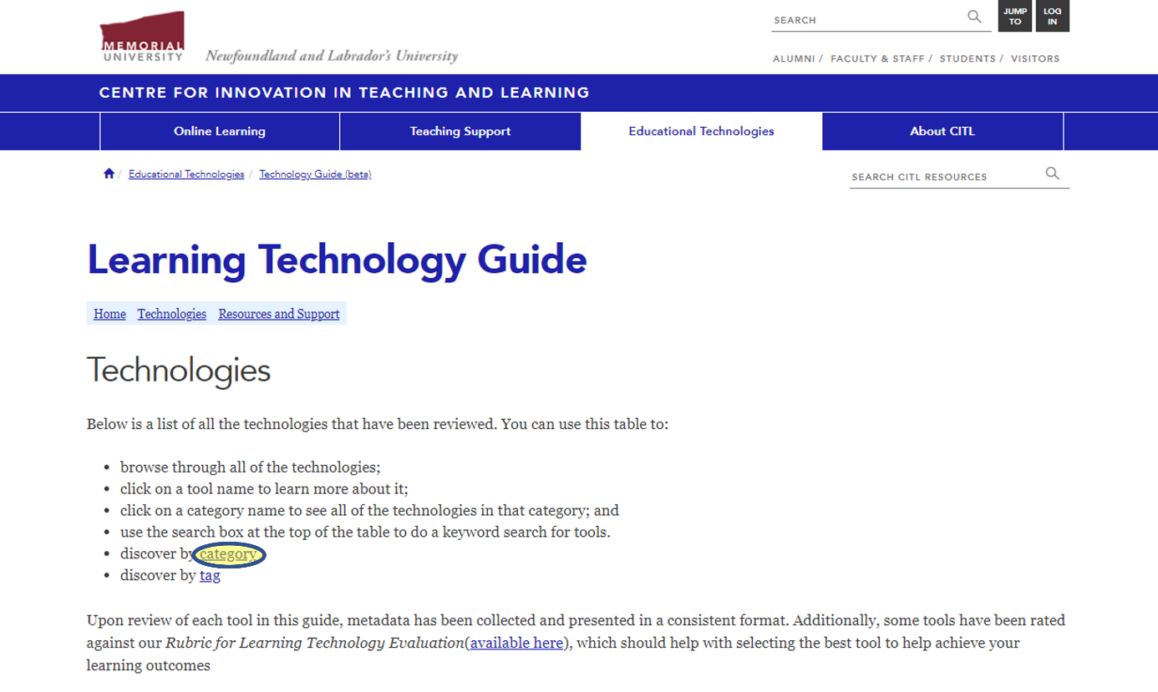
Begin by selecting the category you wish to examine. In this case, we are looking for tools in the category Screencasting. Instructors can select the category to show all researched tools in that category.
The Category Search webpage provides a list of the categories for the investigated and reviewed learning technologies. The list provides the name of the category, the number of learning technologies within that category as well as a description of the types of learning technologies that fall within a specific category. To see the platforms and tools within a category, you can select the name of the category.

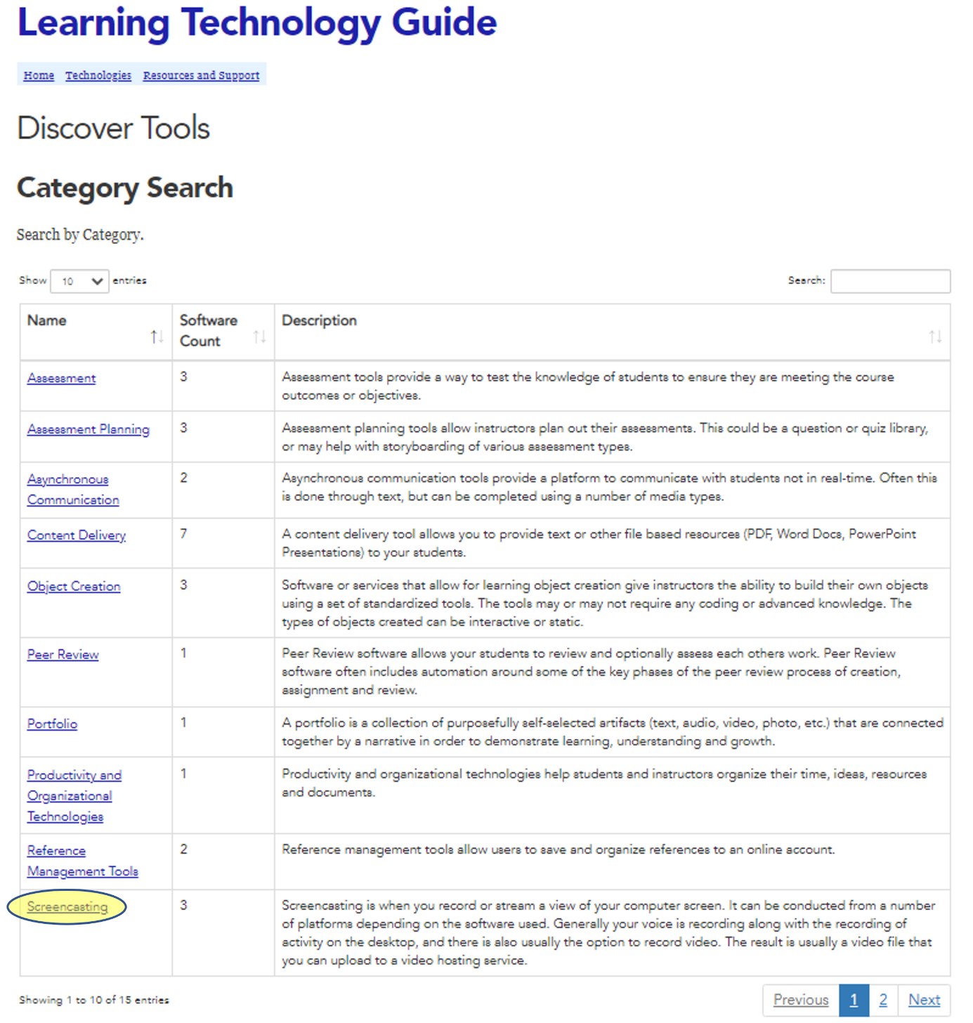

When you search by category, the description of the category will be provided, as well as a list of the researched tools in that category. Each tool is listed by name and has a short description that can help you decide if it is the correct tool for your needs. For more details on a specific tool, you can click on its name. In our case, there are three tools listed in the chosen category.
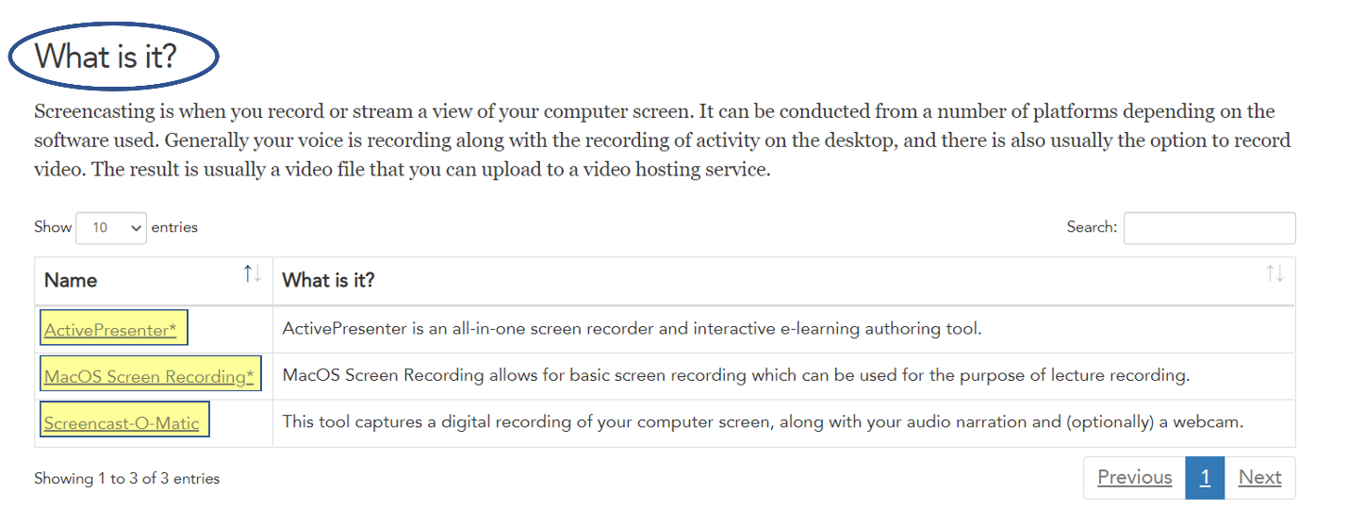
In this scenario, ActivePresenter seems to be a suitable option for our needs, based on the description of the tool. To learn more about the technology, select its name in the chart.
Each Technology Guide entry provides a brief description of the tool, its purpose, and how to get started in using the tool.
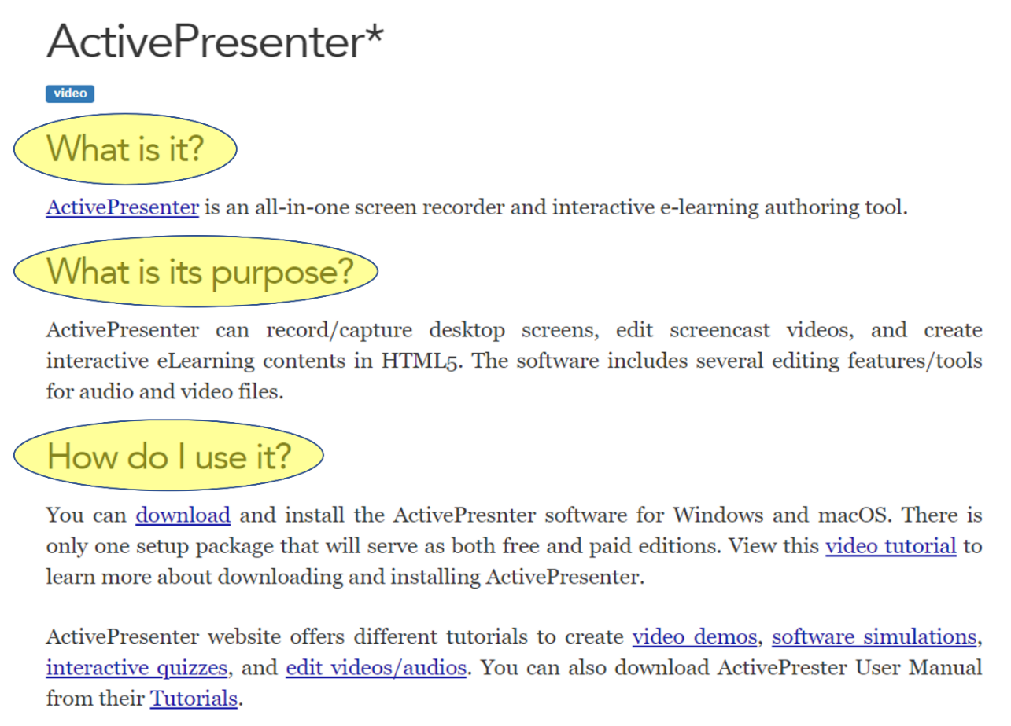
In this example, we can see that ActivePresenter can be used for screen recording that will allow you to record a PowerPoint presentation and your audio and combine them in a video that you can share with your students. The How Do I Use It? section shows that you will need to download this software, as well as which operating systems it can be used on and that there is a free version offered.

The Learning Technology Guide also describes the benefits of using the tool, outlines its usage considerations, provides the ratings information, security and privacy concerns (where applicable), as well as information about where to get support when using the tool.
If a security and privacy concern is indicated the Learning Technology Guide, it means the tool is offered by a third-party and is not directly by Memorial University. In such cases, CITL encourages users to review the tools’ privacy policy and terms and conditions of use prior to use.
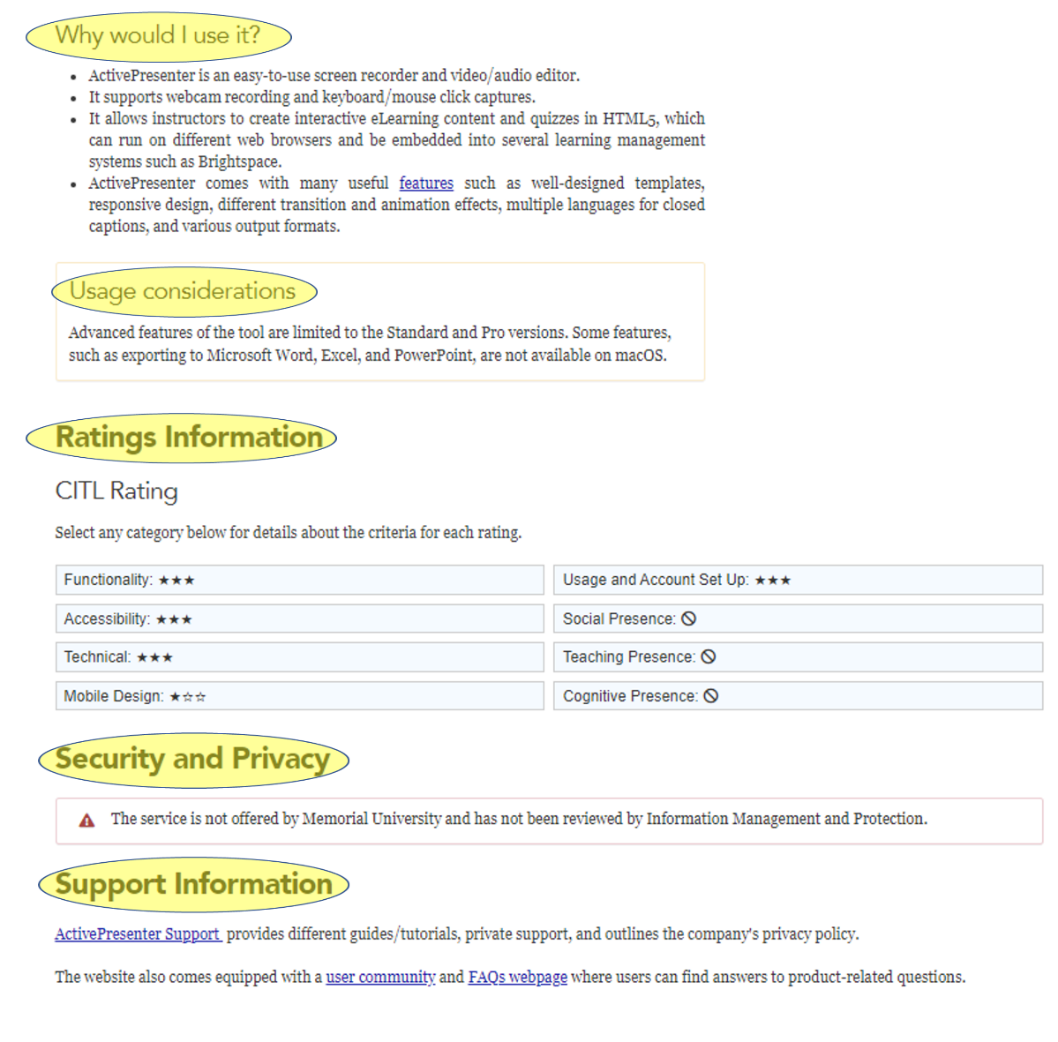

The detailed Ratings Information allows users to see the criteria used to evaluate technologies.
To see the detailed ratings, select the desired criterion in the chart. Three stars (★★★) is the highest rating, and one star (★☆☆) is the lowest. The “prohibited” sign (🛇) shows that the tool is not intended to accomplish the goals of a category. For example, in this scenario, we can see that from the perspective of Accessibility, Active Presenter is ranked high (★★★) and from the perspective of Mobile Design – low (★☆☆) as the platform cannot be used on a mobile device.

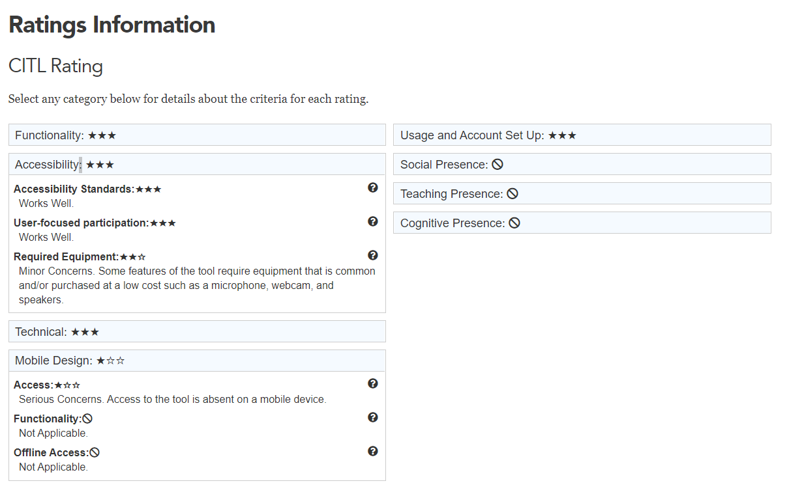

The Quick Facts section of the Learning Technology Guide also provides a link to the website and information about licensing and pricing (if applicable). It also indicates if the tool is supported by CITL, and which platform(s) the tool can be used with.
